Machine Learning Capstone Project
Salary Prediction Using Machine Learning to Reduce Bias in HR Decision-Making

Project Overview:

Business Problem: To ensure there is no discrimination between employees, it is imperative for the Human Resources department of Company X to maintain a salary range for each employee with a similar profile. Apart from the existing salary, a considerable number of factors, such as an employee’s experience and other abilities, are evaluated during interviews. Given the data related to individuals who applied to Company X, models can be built that automatically determine the salary to be offered if a prospective candidate is selected. This model seeks to minimize human judgment in salary decisions.

Goal & Objective: The objective of this exercise is to build a model, using historical data, that will determine the salary to be offered to an employee, minimizing manual judgment in the selection process. The approach aims to be robust and eliminate any discrimination in salary among employees with similar profiles.

CREDIT
NAME-PRINCE KUMAR
EMAIL-HUSTLESPECTRE@GMAIL.COM

Salary Prediction Model

1) Import Libraries
import pandas as pd
import numpy as np
import matplotlib.pyplot as plt
import seaborn as sns

from sklearn.model_selection import train_test_split, GridSearchCV
from sklearn.preprocessing import LabelEncoder
from sklearn.metrics import mean_absolute_error, mean_squared_error, r2_score

from sklearn.linear_model import LinearRegression
from sklearn.ensemble import RandomForestRegressor
import xgboost as xgb
Explain:
- pandas → data manipulation
- numpy → numerical operations
- matplotlib / seaborn → visualization
- sklearn → ML algorithms
- xgboost → advanced gradient boosting model
2) Load Dataset
df = pd.read_csv("expected_ctc.csv")

df.columns = df.columns.str.strip().str.lower()

df.head()
Explain:
- Loads dataset
- Standardizes column names.

3) Data Exploration
df.shape
df.info()
df.describe()
df.isnull().sum()
Explain:
- dataset size
- data types
- summary statistics
- missing values

4) Data Cleaning
Drop unnecessary columns.
df = df.drop(["idx","applicant_id"], axis=1)
Handle missing values.
for col in df.select_dtypes(include=["int64","float64"]):
df[col] = df[col].fillna(df[col].median())

for col in df.select_dtypes(include=["object","str"]):
df[col] = df[col].fillna(df[col].mode()[0])

5) Exploratory Data Analysis (EDA)

Salary Distribution
sns.histplot(df["expected_ctc"], kde=True)
plt.title("Salary Distribution")
plt.show()
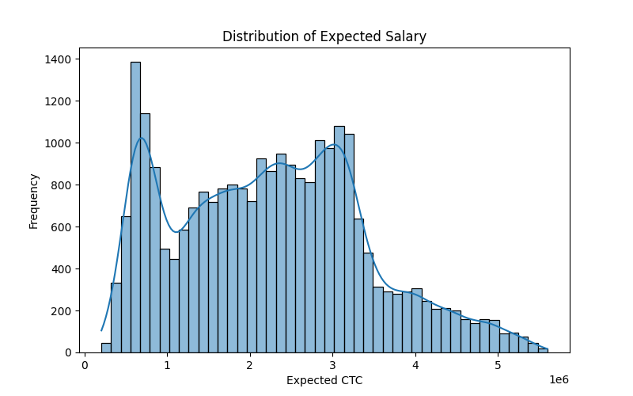

Experience vs Salary
sns.scatterplot(x=df["total_experience"], y=df["expected_ctc"])
plt.title("Experience vs Salary")
plt.show()

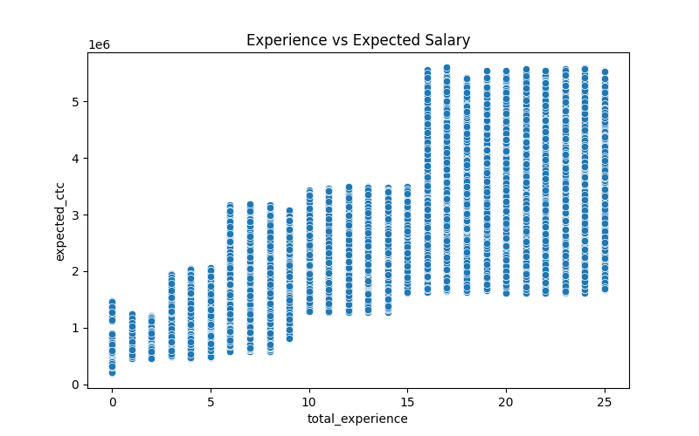

Education vs Salary
sns.boxplot(x=df["education"], y=df["expected_ctc"])
plt.xticks(rotation=45)
plt.show()
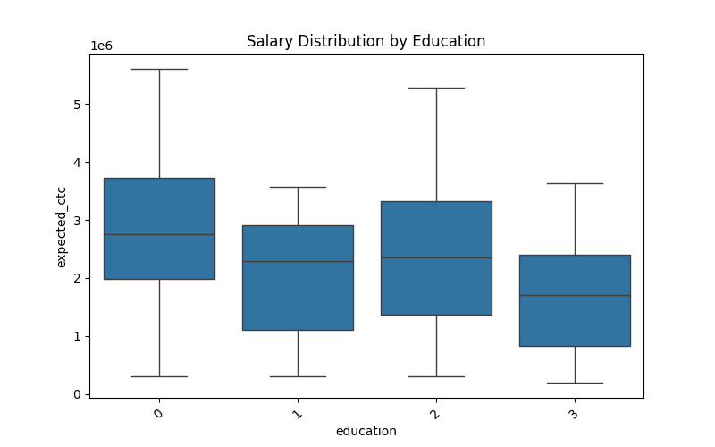

6) Correlation Heatmap
plt.figure(figsize=(12,8))

sns.heatmap(df.corr(), cmap="coolwarm")

plt.title("Feature Correlation Heatmap")

plt.show()
Explain:
- shows relationships between features
- helps detect strong predictors.
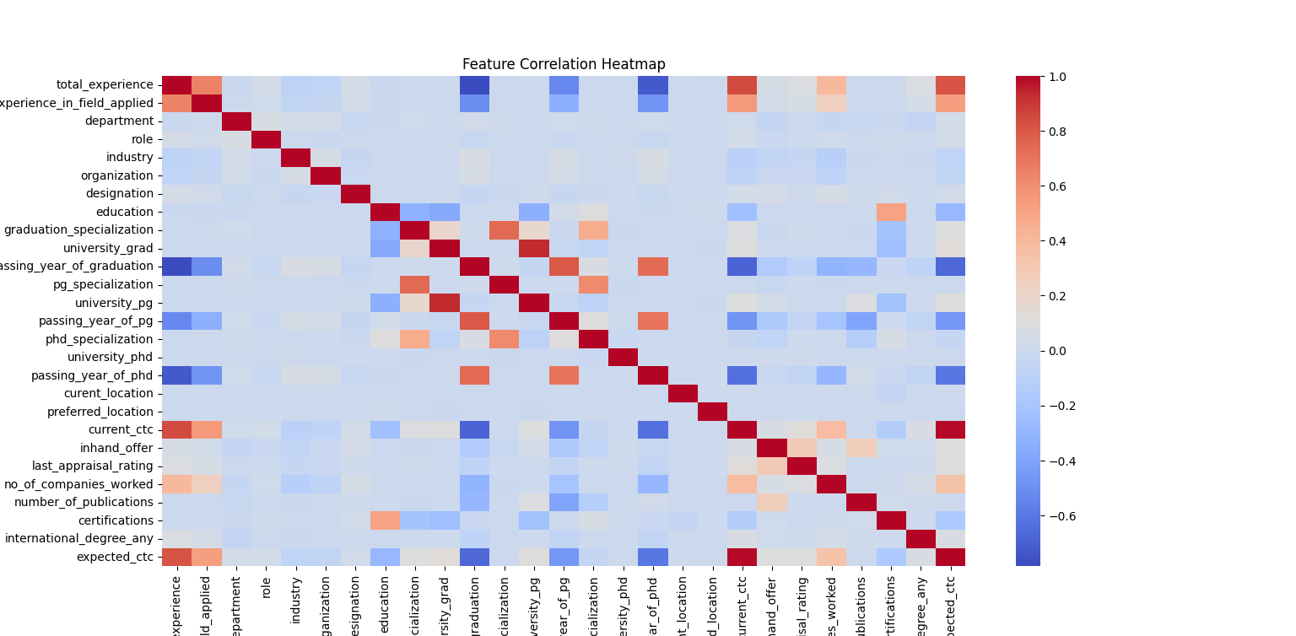

7) Encoding Categorical Variables
le = LabelEncoder()

for col in df.select_dtypes(include=["object","str"]):
df[col] = le.fit_transform(df[col])
Explain:
- ML models require numeric inputs.
8) Feature & Target Variables
X = df.drop("expected_ctc", axis=1)

y = df["expected_ctc"

9) Train-Test Split
X_train, X_test, y_train, y_test = train_test_split(
X, y, test_size=0.2, random_state=42
)
Explain:
- training set → build model
- test set → evaluate model.

10) Model Training

Linear Regression
lr = LinearRegression()
lr.fit(X_train, y_train)

Random Forest
rf = RandomForestRegressor()
rf.fit(X_train, y_train)

XGBoost
xg = xgb.XGBRegressor()
xg.fit(X_train, y_train)

11) Model Evaluation
def evaluate(model):

pred = model.predict(X_test)

print("MAE :", mean_absolute_error(y_test, pred))
print("RMSE:", np.sqrt(mean_squared_error(y_test, pred)))
print("R2 :", r2_score(y_test, pred))
Run:
evaluate(lr)
evaluate(rf)
evaluate(xg)

12) Hyperparameter Tuning (GridSearchCV)
param_grid = {
"n_estimators":[100,200],
"max_depth":[3,5,7],
"learning_rate":[0.01,0.1]
}

grid = GridSearchCV(
xgb.XGBRegressor(),
param_grid,
cv=3,
scoring="r2"
)

grid.fit(X_train, y_train)

best_model = grid.best_estimator_

print(grid.best_params_)

13) Feature Importance
xgb.plot_importance(best_model)

plt.show()
Explain:
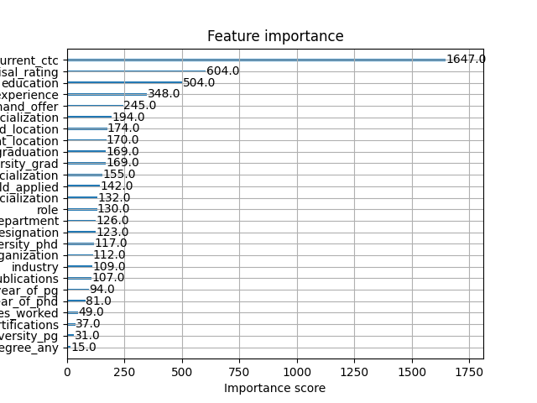
- shows most important predictors.
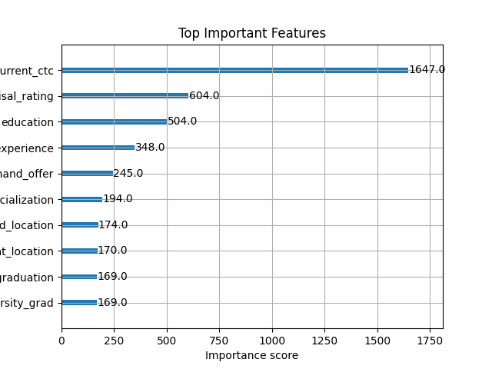
14) Final Model Saving
import joblib

joblib.dump(best_model,"salary_prediction_model.pkl")
Explain:
- saves trained model for future predictions.

15) Conclusion
Example:
In this project, multiple machine learning models were used to predict expected salary. Among the tested models, XGBoost performed best with the highest R² score and lowest prediction error. Feature importance analysis showed that experience, current salary, and appraisal rating significantly influence expected salary.

